Washington State Arts Alliance
Arts and Heritage Day 2019 Hotel Room Blocks
All guests will need valid picture ID and a credit or debit card with their name on it.
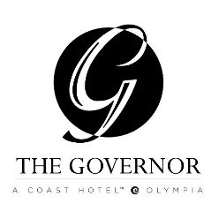
The cut off date for making reservations is 1/31/19. On this date all rooms not reserved will return to available rooms to rent. Call for reservations and mention Arts and Heritage Day
The Governor
621 Capital Ways
Olympia, WA
t: 360-352-7700
$102 for doubles and $112 for singles plus tax available February 5-7

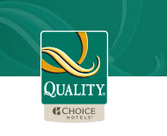
Quality Inn
1211 Quince St. SE
Olympia, WA
t: 360-943-4710
f: 360-943-9349
c: 206-430-0303
$74 Single Queen available February 5-7
$84 Double Queen available February 5-7
6 single queens and 5 more double queens aside for your group. These rates are for up to 2 people there is a $10.00 fee per extra person up to 4 people per double queen rooms. Cut off is January 15th.
All of our rooms have flat screen tvs, refrigerators and microwaves in the room We have free continental breakfast and free wi-fi.

