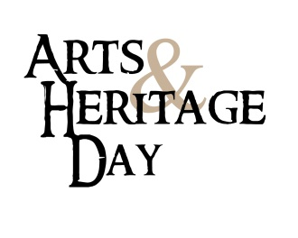

Dear Senator or Representative [last name]:

The Washington State Arts Alliance will hold the annual Arts & Heritage Day on February 7, 2018 in cooperation with the Washington Museum Association, ArtsWA, Humanities WA, Washington State Historical Society, Artist Trust and Arts Ed Washington. Hundreds of Washington’s arts and heritage leaders will come to Olympia on that day to celebrate the intrinsic value of arts, humanities and heritage, and talk with legislators about specific issues impacting our communities, education and the economy.

On behalf of advocates from your district, I would like to request a 15 to 20 minute appointment with you on Wednesday, February 7. We invite you to join us for a gathering in the Washington Room in the Pritchard Building from 11:45 a.m. to 1:00 p.m. You are welcome to say a few words to Arts & Heritage Day attendees.

Also, you are also invited to a reception with Washington’s arts and cultural leaders the evening before on Tuesday, February 6th at the Historic Lord Mansion (formerly the State Capital Museum) 211 21st Avenue SW, Olympia. RSVP contact Susan Rohrer, (360) 586-0116, susan.rohrer@wshs.wa.gov, or http://washingtonmuseumassociation.org/arts-heritage-day/
Thank you for your efforts to keep Washington a great place to work and for supporting the creative industry as an economic engine in our state. We look forward to speaking with you soon.

Sincerely,
[your name]
[your city]

You may also want to include in your email:
- An invitation to visit your organization, tour of the facility, and meet board and staff members.
- An invitation to a performance or reception, and an opportunity to speak to constituents in their district.
- An offer to loan artwork of local artists for display in their Olympia office during the legislative session.

