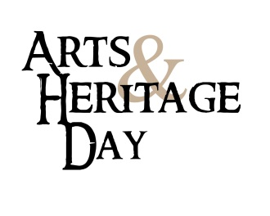

Dear Arts, Humanities and Heritage Advocates,

Arts & Heritage Day is approaching on February 7, 2018! 2018 the activities are in cooperation with, the Washington State Arts Commission, the Washington Museum Association, Humanities WA, Artist Trust, Washington State Historical Society and Arts Ed Washington. This is an exciting all-day event that brings together artists, arts, humanities and heritage leaders, and cultural professionals from across the state.

A reception with legislators will be held the evening prior on Tuesday, February 6 at the Historic Lord Mansion (formerly the State Capital Museum) 211 21st Avenue SW, Olympia. You are welcome to attend. (For more information and RSVP http://washingtonmuseumassociation.org/arts-heritage-day/)

On Wednesday, February 7, Arts & Heritage Day will begin with orientations for participants (Pritchard Building - Washington Room), followed by pre-arranged meetings with legislators throughout the day, lunch on your own with colleagues and friends, maybe even a performance or two!. This is a great opportunity for advocates to talk with their legislators about statewide arts and heritage issues and local concerns, thank them for their support, and share specific stories and highlights from our work in our communities, schools, and venues statewide. Your presence along with many other arts and heritage advocates from across the state helps legislators who we are when we talk about the importance of the arts and heritage in our communities. With newly elected legislators and the reshuffling of legislating positions, this is a particularly important year to join your peers in Olympia.

As we work to confirm appointments with legislators, we are seeking advocates to meet with legislators. (If you have never advocated in Olympia before don’t worry, we will pair newbies with seasoned advocates. It is a great way to learn.) If you are interested in participating on February 7th, please contact me at [your email and phone], and register on the Arts Alliance website at www.washingtonstateartsalliance.org.

The Draft Issues Brief will be available on the Arts Alliance website towards the end of January. Please note that issues brief will change in the weeks ahead.

In your response please include:
- Your name
- Are you willing to lead the meeting?
- Your home district and your work district. If you don’t know your district you may find here: http://apps.leg.wa.gov/districtfinder.
- Would you like to carpool?

If you’re unable to attend but would still like to help, please forward this email to other arts supporters in your district. Please have them get in contact with me if they would like to participate in Arts and Heritage Day.

We truly appreciate your work on behalf of public support for the arts humanities and heritage in
Washington, and we look forward to seeing you in Olympia on February 7.

Sincerely,
[your name]
Team Captain of districts [districts in your region]

